**Models and their Results NLP+DL Project**

BERT & BiLSTM

BERT & CNN

Dataset loaded. Shape: (29999, 2)

Unique labels: {0, 1}

==================================================

EPOCH 1/3

==================================================

Training Epoch 1: 100%|█████████████████████████████████████████████████| 1500/1500 [59:33<00:00, 2.38s/it, loss=0.0473]

Average training loss: 0.3129

=== Evaluation Metrics ===

Accuracy: 0.9703283880646775

Classification Report:

precision recall f1-score support

0 0.99 0.96 0.97 3138

1 0.95 0.99 0.97 2861

accuracy 0.97 5999

macro avg 0.97 0.97 0.97 5999

weighted avg 0.97 0.97 0.97 5999

Confusion Matrix:

[[2997 141]

[ 37 2824]]

ROC-AUC: 0.9970

MSE: 0.0284

MAE: 0.0943

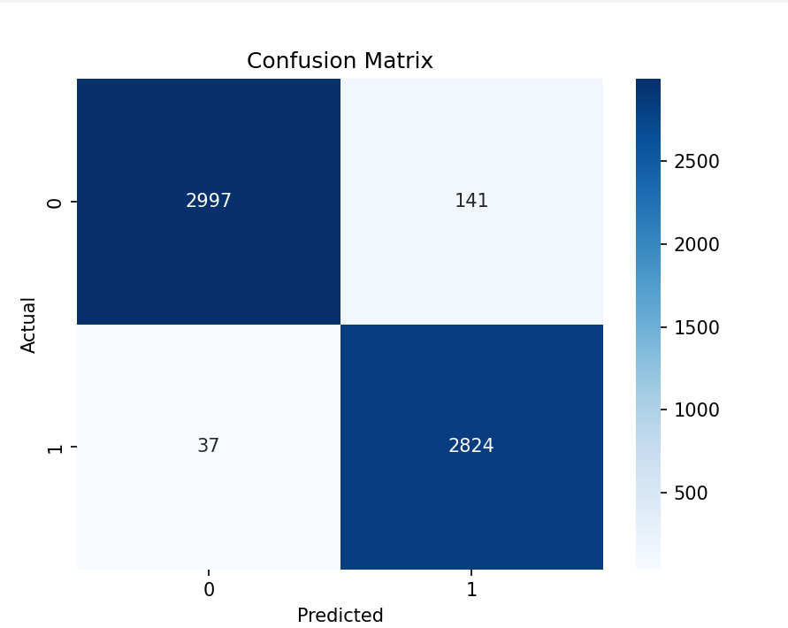

GRU & Glove

Epoch 1/5

225/225 - 87s - 385ms/step - accuracy: 0.9310 - loss: 0.1707 - val_accuracy: 0.9873 - val_loss: 0.0438

Epoch 2/5

225/225 - 83s - 370ms/step - accuracy: 0.9913 - loss: 0.0276 - val_accuracy: 0.9929 - val_loss: 0.0192

Epoch 3/5

225/225 - 84s - 375ms/step - accuracy: 0.9961 - loss: 0.0127 - val_accuracy: 0.9960 - val_loss: 0.0115

Epoch 4/5

225/225 - 411s - 2s/step - accuracy: 0.9970 - loss: 0.0095 - val_accuracy: 0.9958 - val_loss: 0.0101

Epoch 5/5

225/225 - 68s - 301ms/step - accuracy: 0.9973 - loss: 0.0088 - val_accuracy: 0.9974 - val_loss: 0.0078

281/281 ━━━━━━━━━━━━━━━━━━━━ 9s 33ms/step

Classification Report:

precision recall f1-score support

0 1.00 1.00 1.00 4710

1 1.00 0.99 1.00 4270

accuracy 1.00 8980

macro avg 1.00 1.00 1.00 8980

weighted avg 1.00 1.00 1.00 8980

F1 Score: 0.996832101372756

Accuracy: 0.9969933184855234

Mean Squared Error (MSE): 0.0022884313948452473

Mean Absolute Error (MAE): 0.004307237919420004

RoBERTA & BiLSTM

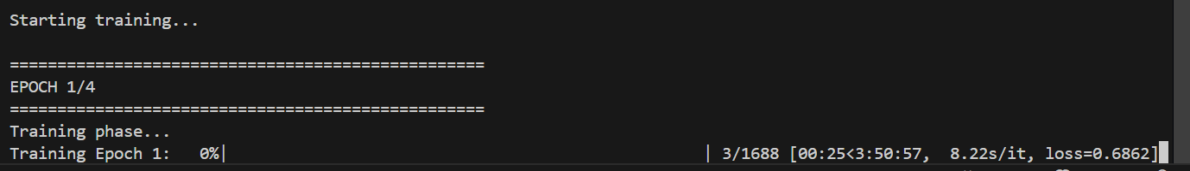

Epoch 1/2: 0%| | 0/600 [00:00<?, ?it/s]d:\D Drive (Dhaval)\Research & Review Papers\NLP + DL Research Paper Misinformation Detection\Uni Modal\Final Project Implementation\Models\RoBERTa & BiLSTM\train.py:105: FutureWarning: `torch.cuda.amp.autocast(args...)` is deprecated. Please use `torch.amp.autocast('cuda', args...)` instead.

with torch.cuda.amp.autocast(enabled=USE_AMP):

C:\Users\Dhaval Mehta\AppData\Roaming\Python\Python312\site-packages\torch\amp\autocast_mode.py:266: UserWarning: User provided device_type of 'cuda', but CUDA is not available. Disabling

warnings.warn(

Epoch 1/2: 100%|███████████████████████████████████████████████████████████| 600/600 [27:25<00:00, 2.74s/it, loss=0.494]

Epoch 1 | Avg Train Loss: 0.5179

Epoch 2/2: 100%|██████████████████████████████████████████████████████████| 600/600 [11:56<00:00, 1.19s/it, loss=0.0339]

Epoch 2 | Avg Train Loss: 0.1751

✅ Training Complete (FAST VERSION)

=== Running Evaluation on Validation Set ===

=== Evaluation Metrics ===

Accuracy: 0.9566666666666667

Classification Report:

precision recall f1-score support

0 0.9694 0.9438 0.9564 605

1 0.9444 0.9697 0.9569 595

accuracy 0.9567 1200

macro avg 0.9569 0.9568 0.9567 1200

weighted avg 0.9570 0.9567 0.9567 1200

Confusion Matrix:

[[571 34]

[ 18 577]]

ROC-AUC: 0.9910

MSE: 0.0356

MAE: 0.0825

RMSE: 0.1888

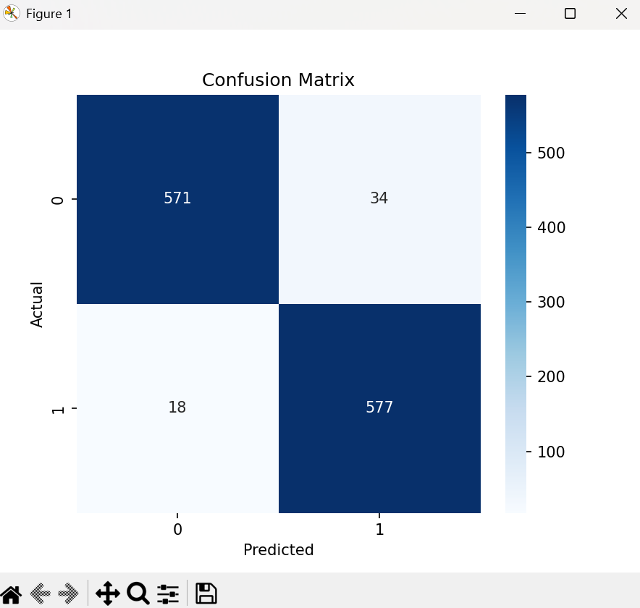

Word2Vec & LSTM

Dataset loaded: (29999, 2)

🔤 Preparing text for Word2Vec training...

🧠 Training custom Word2Vec model...

✅ Word2Vec trained! Vocabulary size: 69996

💾 Custom Word2Vec saved to: d:\D Drive (Dhaval)\Research & Review Papers\NLP + DL Research Paper Misinformation Detection\Uni Modal\Final Project Implementation\Models\Word2Vec & LSTM\custom_word2vec.model

Embedding coverage: 69996/147531 (47.4%)

Dataset created with 23994 samples

Dataset created with 5999 samples

🚀 Starting LSTM training...

Epoch 1/3

Training: 100%|████████████████████████████████████████████████████████████████████████| 750/750 [05:14<00:00, 2.38it/s]

Average Loss: 0.1412

=== Evaluation Metrics ===

Accuracy: 0.981663610601767

Classification Report:

precision recall f1-score support

0 0.97 0.99 0.98 3138

1 0.99 0.97 0.98 2861

accuracy 0.98 5999

macro avg 0.98 0.98 0.98 5999

weighted avg 0.98 0.98 0.98 5999

Confusion Matrix:

[[3109 29]

[ 81 2780]]

ROC-AUC: 0.9986

MSE: 0.0136

MAE: 0.0248

RMSE: 0.1168

Validation Accuracy: 0.9817

Epoch 2/3

Training: 100%|████████████████████████████████████████████████████████████████████████| 750/750 [04:08<00:00, 3.01it/s]

Average Loss: 0.1194

=== Evaluation Metrics ===

Accuracy: 0.9861643607267878

Classification Report:

precision recall f1-score support

0 0.99 0.98 0.99 3138

1 0.98 0.99 0.99 2861

accuracy 0.99 5999

macro avg 0.99 0.99 0.99 5999

weighted avg 0.99 0.99 0.99 5999

Confusion Matrix:

[[3081 57]

[ 26 2835]]

ROC-AUC: 0.9985

MSE: 0.0116

MAE: 0.0218

RMSE: 0.1079

Validation Accuracy: 0.9862

Epoch 3/3

Training: 100%|████████████████████████████████████████████████████████████████████████| 750/750 [04:27<00:00, 2.81it/s]

Average Loss: 0.0202

=== Evaluation Metrics ===

Accuracy: 0.9901650275045841

Classification Report:

precision recall f1-score support

0 0.99 0.99 0.99 3138

1 0.99 0.99 0.99 2861

accuracy 0.99 5999

macro avg 0.99 0.99 0.99 5999

weighted avg 0.99 0.99 0.99 5999

Confusion Matrix:

[[3111 27]

[ 32 2829]]

ROC-AUC: 0.9992

MSE: 0.0083

MAE: 0.0106

RMSE: 0.0912

Validation Accuracy: 0.9902

✅ Model saved!